1. On the sign in page can you please make sure that all of the font in the boxes is black color #333333 and easy to read

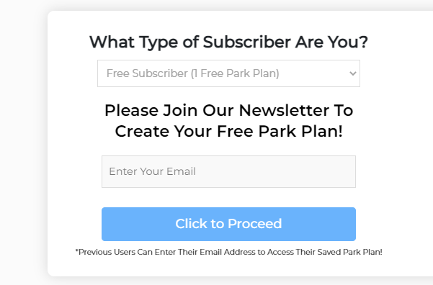

1. When someone uses the Free Subscriber can you please add a check box down below which says “ By checking this box you agree to join The Park Prodigy Newsletter! (P.S. We will never spam you)

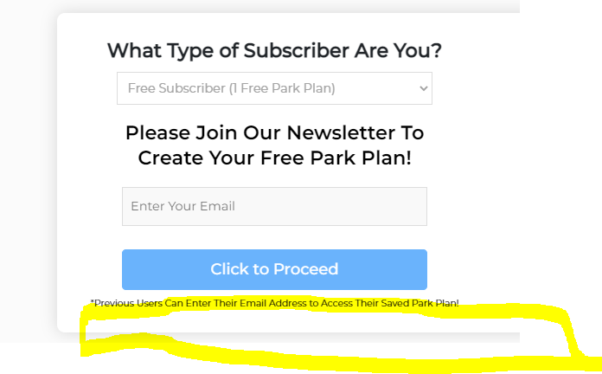

1. Also on the mobile version of the page can we please make the calendar smaller so that it fits on the page like we have on the tickets pages:

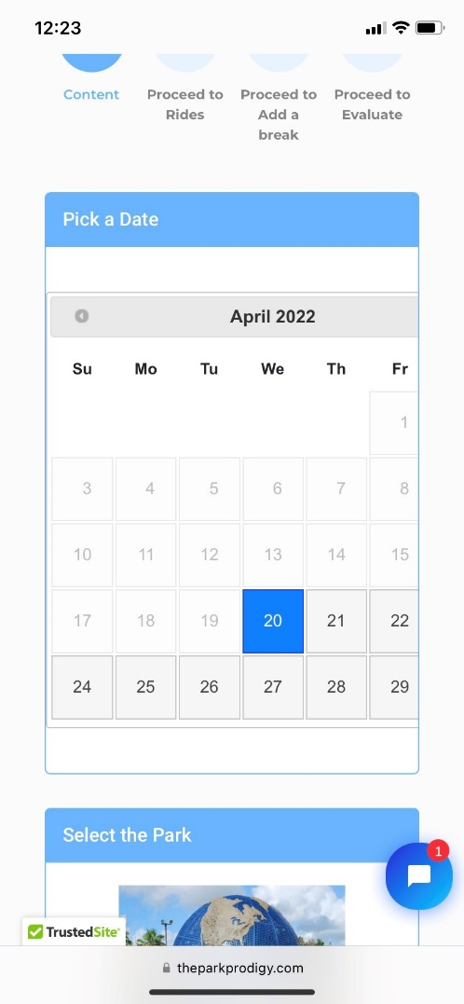

1. Then once the user gets to the plan can you please make the information presented easier? Right now it is cut off and only the blue line allows for you to scroll over which is confusing:

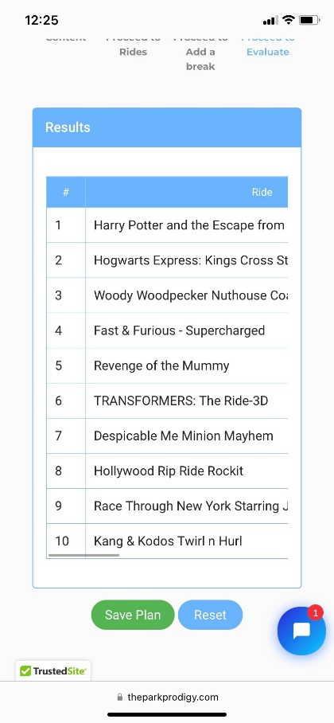

1. Can you please put a rule in place for when someone selects the Early Park Hours for Universal Studios and Islands of Adventure? During the extra hour only specific rides are open so can you please make sure that we only include the below list of rides in the first hour of the day when user selects Yes for Early Park Hours

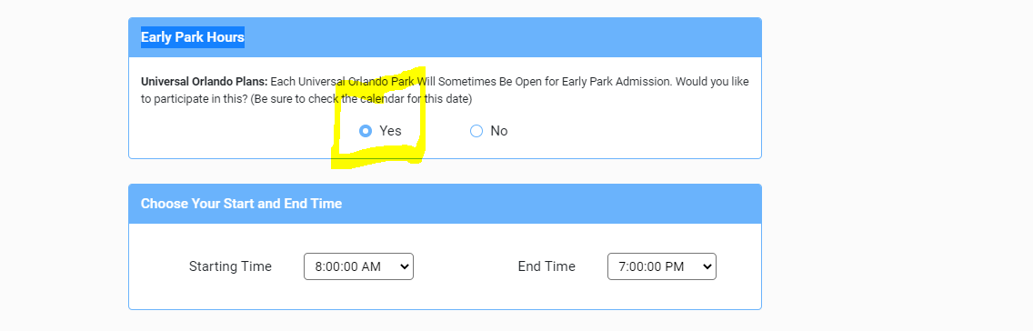

Below are the rides that user can go on during the first hour of the day when user selects yes

**Universal Studios Rides For Early Hour**

Harry Potter and the Escape from Gringotts

Despicable Me Minion Mayhem

**Islands of Adventure Rides For Early Hour**

Flight of the Hippogriff

Hagrid's Mafical Creatures Motorbike Adventure

Harry Potter and the Forbidden Journey  
Jurassic World VelociCoaster

1. Can we add the park logo on the top left corner of each park plan based on which plan the user is creating. Please use the following images for each park:

Universal Studios: https://theparkprodigy.com/wp-content/uploads/2021/09/3-park.png

Islands of Adventure: <https://theparkprodigy.com/wp-content/uploads/2021/09/3-park-1.png>

1. When someone hits the email button can you please change the successful message to this:

“Your custom park plans have been sent! Be sure to check your spam box if you don’t see it right away!”

Also can you please have this message stay up after they email it

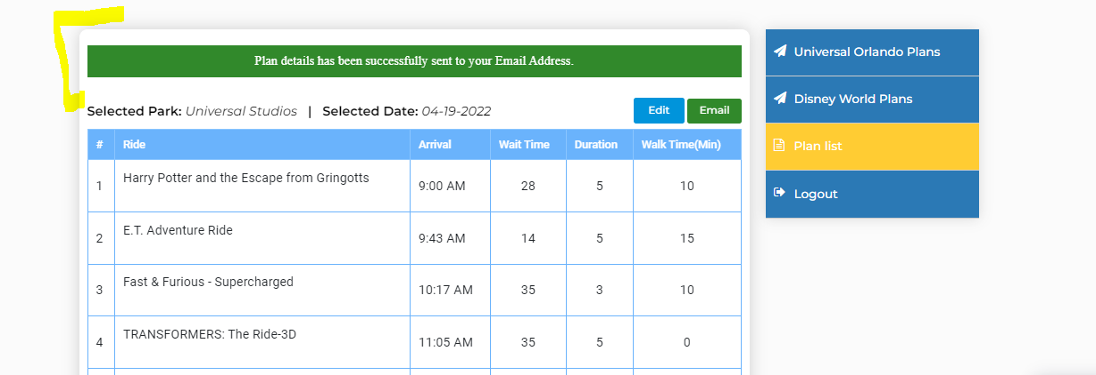

1. Next can you please help me update the emails we are sending out with the park plans.

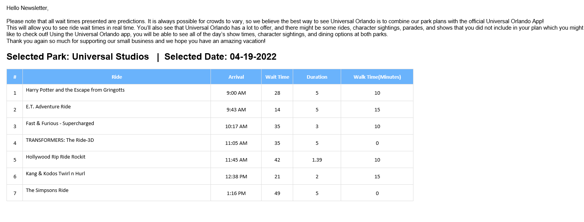

**Please update the opening paragraph to say the following and please have the spaces inbetween each section**

Hello _____,

Below is your custom park plan for your Universal Orlando trip! Please note that all wait times presented are predictions. It is always possible for crowds to vary, so we believe the best way to see Universal Orlando is to combine our park plans with the official Universal Orlando App!

This will allow you to see ride wait times in real time. You’ll also see that Universal Orlando has a lot to offer, and there might be some rides, character sightings, parades, and shows that you did not include in your plan which you might like to check out! Using the Universal Orlando app, you will be able to see all of the day’s show times, character sightings, and dining options at both parks.

Thank you again so much for supporting our small business and we hope you have an amazing vacation!

1. Then can you please add the below sections at the bottom of every email after the park plans

**Universal Orlando App Information**

Whether you’re still planning your trip or already here, our official app is the ultimate must-have.

**Place Mobile Food and Drink Orders**

Order ahead from select restaurants when you’re in the parks and CityWalk.

**Get a Virtual Line™ Return Time**

**Find Everything You Need**

Find wait times updated in real-time, and even set alerts for when the wait reaches a specific time. For instance, you can set the app to notify you when the Fast & Furious ride reaches a 30-minute wait.

See all the details of every attraction: height restrictions, type of ride, as well as ride specifications like Virtual Line, if it accepts Express Pass or has Child Swap available.

Use filters to find and sort by park, ride type, shows, dining and shopping. Locate all restrooms, including family restrooms.

Set a parking reminder to find your car by section, level and row

.

**Create a Favorites Ride List**

Add to your My Favorites list by marking your top rides, attractions and more with a heart.

**Always Be In The Know**

Make sure you have notifications enabled in your device settings so you can stay up-to-date with all things Universal Orlando.

## Virtual Line

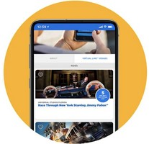The Virtual Line is a feature that allow guests to avoid waiting in line at certain rides! You will be able to choose a return time for select attractions at Universal Studios Florida and Universal’s Islands of Adventure.

Here’s to get a Virtual Line Return Time through the Universal Orlando App:

1. In the app’s left-hand menu, select “Virtual Line.”
2. Tap on the “Virtual Line Venues” tab to see a list of available attractions.
3. 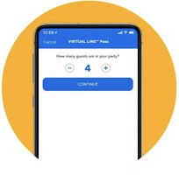Select the attraction you want to ride and tap “Virtual Line Pass – Reserve”
4. Set Your Pass Details
5. Head to the Attraction when it’s Your Time to Ride. Once your time has passed, you can get another Virtual Line return time.

Please note the scheduler feature only works only in the parks (although you don't have to be at the attraction).

At this time, the rides that require Virtual Line are: Hagrid's Magical Creatures Motorbike Adventure Revenge of The Mummy

Race Through NY Starring Jimmy Fallon

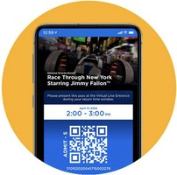As rides may vary and Virtual Line Times may run out, we strongly recommend checking in the app once you arrive at the parks and get the one for the Hagrid ride. If you arrive during Early Park Admission and lines aren't available yet, you may need to wait until the park fully opens.

Find some additional information here: <https://theparkprodigy.com/universal-virtual-line/>